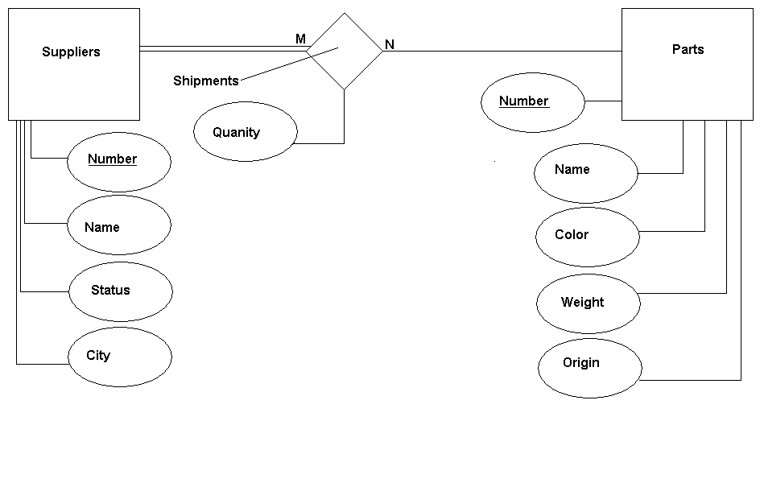
Name Timothy Beckett
Class CSCI 4560
Instructor Dr. Cripps
Assignment 1 ER Design of database
Part 1

